Fixed Deposit Error AIP at OLP: not drawdown AIP Amount to Saving Account on Rollover Date:

Customer Name: HSIAO WENHSIEN

Customer Acc.: 460000004597

Error AMT: 367.61

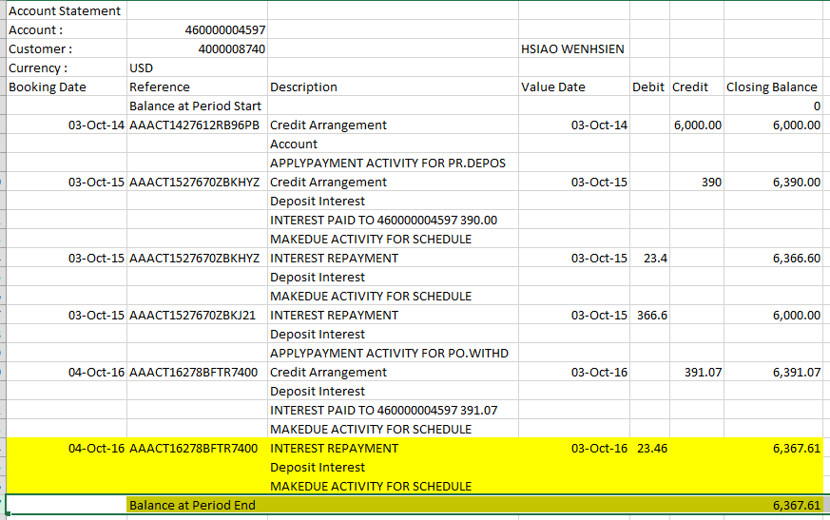

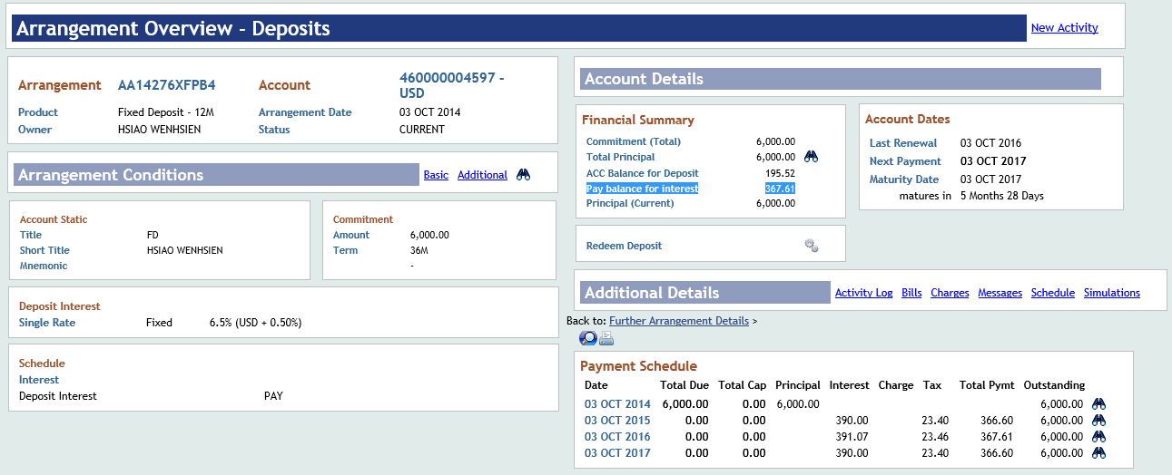

Saving Account:

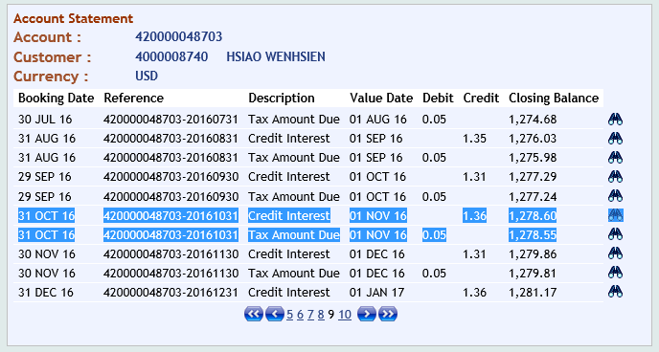

CRB:

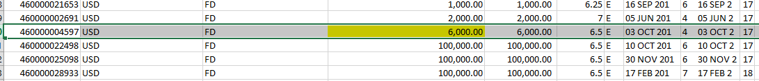

Saving Listing:



Difference:

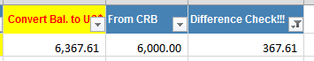

5634-323130

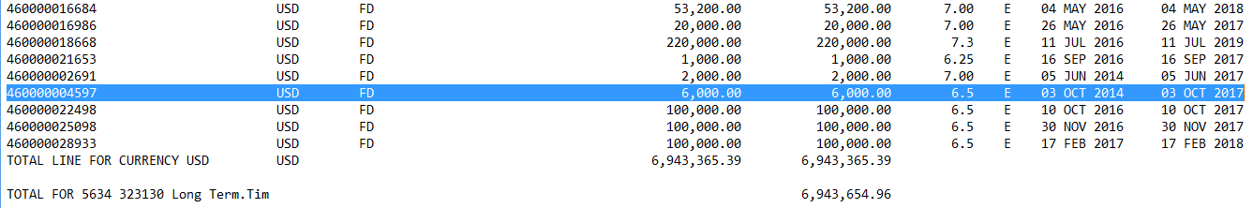

6538-344330-AIP

